Parkinson’s disease: in-class exercise

Project 1: Identification of Tear Biomarkers for Individuals with Parkinson's Disease

Study Rationale:
Prior to the appearance of classic movement abnormalities like tremor and slowness, those with Parkinson's suffer from non-motor symptoms, such as altered function of the gastrointestinal tract, depression and changes in the sense of smell. The secretion of specific proteins into tears may be regulated by similar changes in nerve function that are seen in these other affected systems. Thus, an analysis of alterations in the secretion of proteins into tears may lead to the identification of a reliable biomarker (tracks disease activity) for Parkinson's disease (PD).

Hypothesis:
As PD affects multiple non-motor systems, tear secretion in those with Parkinson's will be altered to exhibit a characteristic or diagnostic biomarker profile that will be reflected in changes in the protein composition of tear fluid, which can be measured relatively easily, cost-effectively and non-invasively.

Study Design:
Tear fluid samples will be collected from participants with Parkinson's, and, through biochemical assays, the profile of proteins in tears will be characterized and compared to those from control participants. The profiles will be analyzed with respect to differences between participants with Parkinson's and control participants. If differences are found, the levels of these potential biomarkers in Parkinson's will be analyzed with respect to disease severity.

Impact on Diagnosis/Treatment of Parkinson's Disease:
There are currently no biomarkers for the detection of Parkinson's. Identification of reliable biomarkers for PD would allow for earlier detection and treatment of and monitoring of drug-based interventions, potentially leading to better outcomes.

Next Steps for Development:
Biomarkers for Parkinson's, if present in tears, may be used to screen for early detection of the disease, to monitor the course of disease and to measure the effectiveness of potential therapeutic treatments. These evaluations will be non-invasive, relatively easy to perform and cost-effective.

Project 2: Diffusion Tensor-based Biomarker for Parkinson's Disease

Objective/Rationale:
Magnetic resonance imaging (MRI) is a common tool used to diagnose or evaluate brain diseases such as Parkinson’s disease. Typically, MRI images are read by a radiologist. However, imaging techniques often provide large amounts of information to sort through, such as how certain areas of the brain are connected, that are difficult for a human viewer to visualize. This is the case with diffusion tensor imaging (DTI), a kind of MRI. The purpose of this project is to optimize DTI to improve our abilities to identify Parkinson’s disease and to follow progression of disease.

Project Description:
Our laboratory is using high-performance computing (such as supercomputers) to highlight differences so that they can be more easily visualized by a human viewer. We are also using the computer analysis to evaluate probability. The computer may be used to evaluate the chance, for example, that a particular brain would be seen in an individual with Parkinson’s disease. We are combining the computer predictions with other markers of disease (in this case spinal fluid proteins such as alpha-synuclein) to see how well we can predict presence of disease and how accurate we might be in measuring and ultimately predicting progression of disease.

Relevance to Diagnosis/Treatment of Parkinson’s Disease:
One serious problem in developing new treatments for Parkinson’s disease is that we don’t have very good measures of brain change over time. We propose that DTI, which gives us a lot of complex, interconnected information about brain structure and function, will be able to provide these sorts of measures, particularly as we begin to combine imaging with other markers of disease such as spinal fluid disease markers.

Anticipated Outcome:
This project will show us if DTI has the potential be used as a biomarker tool for detection of Parkinson’s disease. The project will additionally show us if DTI has the potential to be used to track disease progression in Parkinson’s disease. We will also evaluate the potential for imaging biomarkers to be combined with other biomarkers of disease such as blood and spinal fluid markers.

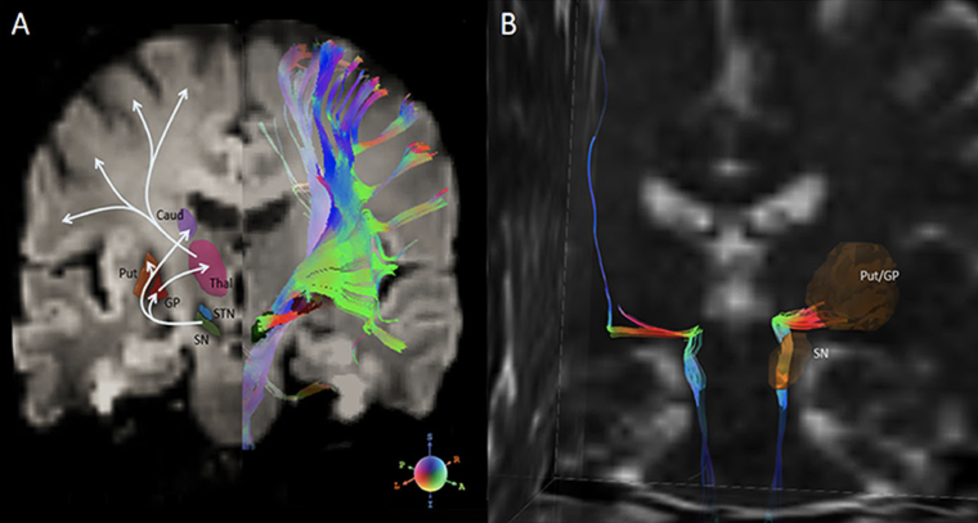

Project 3: pS65-Ubiquitin as a Biomarker for Parkinson's Disease

Study Rationale:
The PINK1 and parkin proteins jointly ensure quality control of mitochondria, the cell's powerhouse. Together they modify damaged mitochondria with phosphorylated ubiquitin (pS65-Ub), which appears to label the mitochondria for degradation. In some genetic forms of Parkinson's, PINK1 and parkin activity is lost, and mitochondrial dysfunction is seen in the broader Parkinson's population.

Hypothesis:
Given that pS65-Ub is a quantitative marker of mitochondrial damage, we hypothesize that pS65-Ub might be useful as a novel biomarker for Parkinson's disease.

Study Design:
In this proof-of-concept study, we aim to develop and optimize antibody-based assays to reliably quantify pS65-Ub from cells and different patient samples. We will determine the best assay conditions and antibody combinations, and assess their suitability as biomarkers for Parkinson's disease.

Impact on Diagnosis/Treatment of Parkinson's Disease:
Currently there are no biomarkers available for Parkinson's disease. However, these would be extremely valuable to diagnose and stratify patients as well as to the future development of therapies.

Next Steps for Development:
Upon successful development and optimization of the pS65-Ub assays and exploration of diverse patient specimens (cells, blood, cerebrospinal fluid) with limited sample numbers, next steps will include expansion to larger sample sizes of the respective specimens to establish pS65-Ub as a biomarker for Parkinson's.

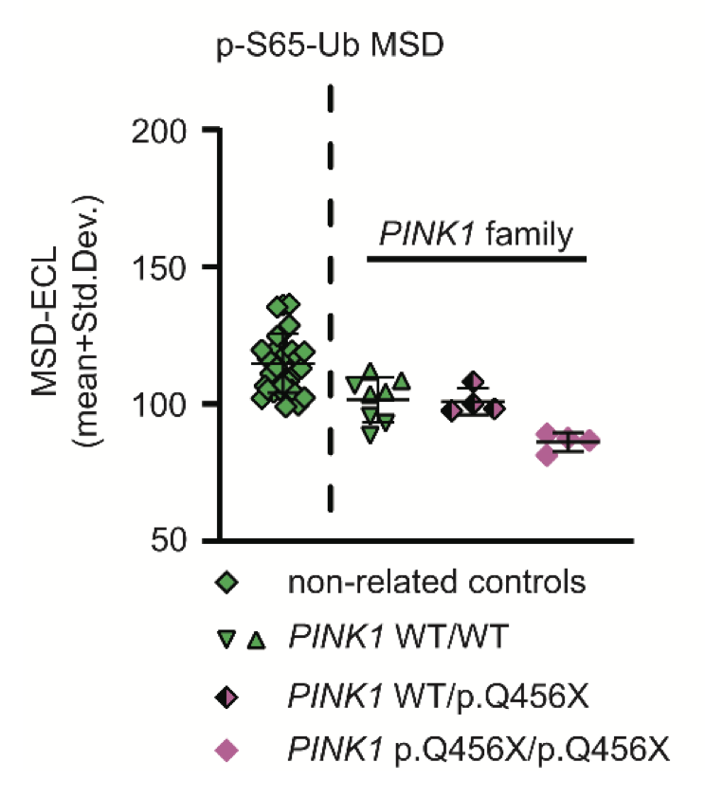

Project 4: Corneal Confocal Microscopy: A Novel Imaging Biomarker for Parkinson's Disease

Study Rationale:
We have pioneered a technique in which we can photograph nerves on the surface of the eye. This technique can be used to monitor the severity of various neurological conditions. In our previous work, we have shown that nerves on the surface of the eye are damaged in Parkinson's disease (PD); this damage is more severe in individuals with more advanced symptoms of PD.
In this study, we aim to determine how quickly and how reliably these nerves become damaged in PD. We will perform clinical examinations on participants and take photographs of the surface of the eye using a specialized camera at baseline, one year and two years.

Hypothesis:
We aim to validate the use a photograph of the surface of the eye to monitor the progression of PD in a manner that is more accurate and cost-efficient than is currently possible with clinical examination and/or brain scans.

Study Design:
Individuals with early PD (less than five years after diagnosis) will be recruited as participants. They will undergo clinical examination and photographs will be taken of the surface of the eye. Participants will return for follow up one year later and two years later to undergo the same evaluation. We aim to demonstrate how quickly and reliably the nerves on the surface of the eye become damaged and how this relates to changes in PD symptoms.

Impact on Diagnosis/Treatment of Parkinson's disease:
Many new drugs are being developed that may slow PD progression. Currently, the main way to measure whether these drugs are working is to examine individuals at regular intervals but this examination varies greatly from one day to the next, such that it takes hundreds of participants over several years to find out if a new drug works. We hope to use a simple eye test to measure whether these drugs can slow nerve damage associated with PD. By using a more reliable and accurate measure, we hope to make an earlier diagnosis possible and to improve clinical trials to speed up the approval of new drugs.

Next Steps for Development:
If we demonstrate that we can monitor PD by studying the nerves on the surface of the eye, the next stage will be to perform a larger follow-up study and evaluate the ability of this test in early phase clinical trials of new PD drugs.

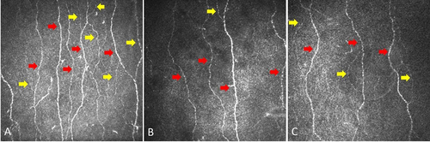

Project 5: Assessment of heterogeneity among Parkinson's disease cohort using α-synuclein seed amplification

Study Rationale: Emerging evidence shows that α-synuclein seed amplification assays (SAAs) have the potential to differentiate people with Parkinson's disease from healthy controls. We used the well characterised, multicentre Parkinson's Progression Markers Initiative (PPMI) cohort to further assess the diagnostic performance of the α-synuclein SAA and to examine whether the assay identifies heterogeneity among patients and enables the early identification of at-risk groups.

Study Design:
We assessed the sensitivity and specificity of the α-synuclein SAA in participants with Parkinson's disease and healthy controls, including subgroups based on genetic and clinical features.
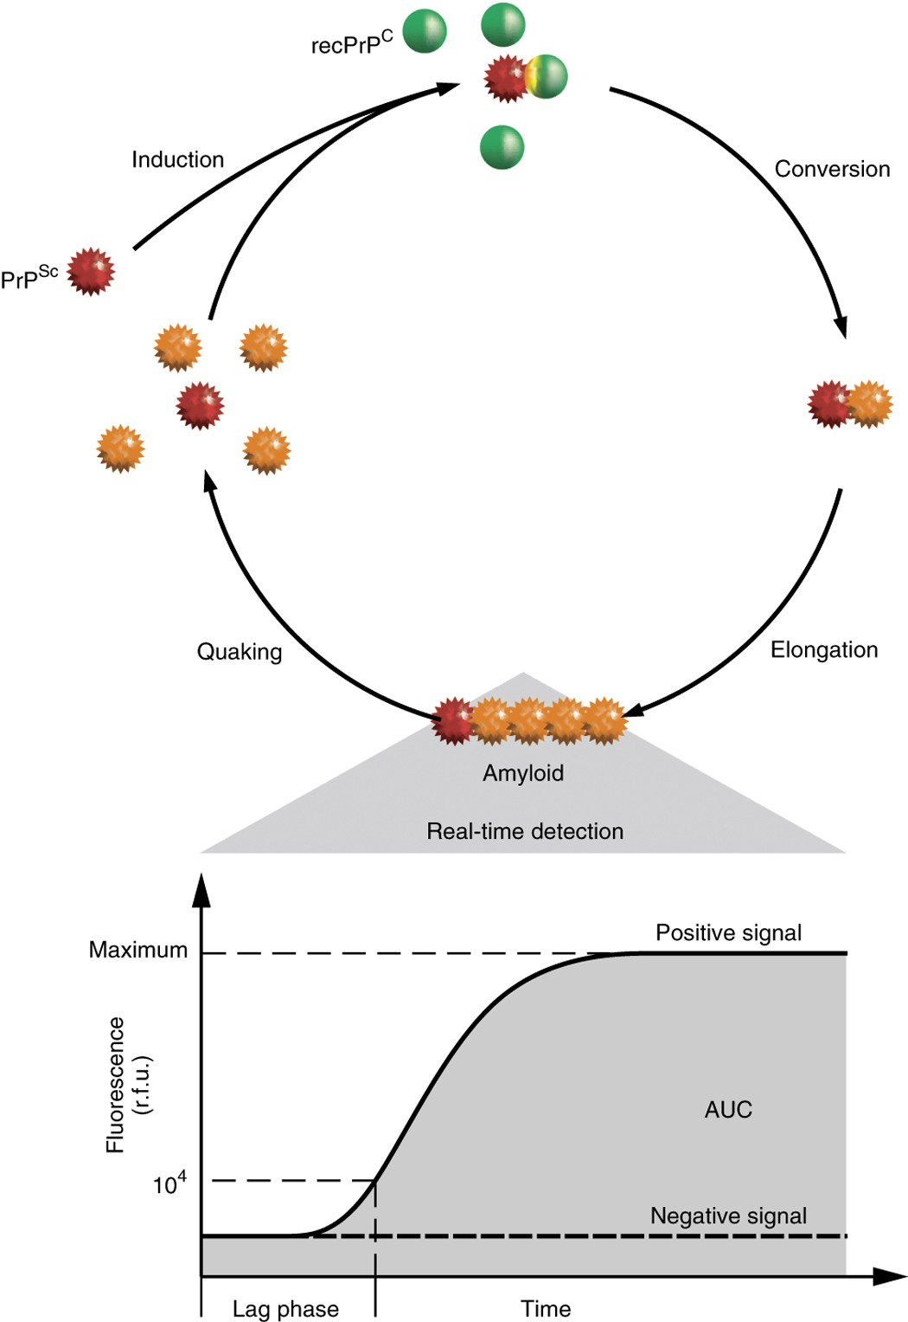
This analysis included 1123 participants. Of these, 545 had Parkinson's disease, 163 were healthy controls, 54 were participants with scans without evidence of dopaminergic deficit, 51 were prodromal participants, and 310 were non-manifesting carriers. Sensitivity for Parkinson's disease was 87·7% (95% CI 84·9–90·5), and specificity for healthy controls was 96·3% (93·4–99·2). The sensitivity of the α-synuclein SAA in sporadic Parkinson's disease with the typical olfactory deficit was 98·6% (96·4–99·4). The proportion of positive α-synuclein SAA was lower than this figure in subgroups including LRRK2 Parkinson's disease (67·5% [59·2–75·8]) and participants with sporadic Parkinson's disease without olfactory deficit (78·3% [69·8–86·7]).

Impact on Diagnosis/Treatment of Parkinson’s disease:
This study represents the largest analysis so far of the α-synuclein SAA for the biochemical diagnosis of Parkinson's disease. Our results show that the assay classifies people with Parkinson's disease with high sensitivity and specificity, provides information about molecular heterogeneity, and detects prodromal individuals before diagnosis. These findings suggest a crucial role for the α-synuclein SAA in therapeutic development, both to identify pathologically defined subgroups of people with Parkinson's disease and to establish biomarker-defined at-risk cohorts.

Project 6: Alpha-Synuclein PET Tracer Discovery

Study Rationale: The discovery of new treatments for Parkinson’s disease has been slowed by the time it takes to answer the question “did a drug work” in a clinical trial. Tests that can assess whether a new treatment is working would speed the pace of clinical trials in Parkinson’s. The studies described in this project aim to develop a new imaging test that to measure toxic clumps of alpha-synuclein protein (a defining marker of Parkinson’s) in the brain of living patients.

Hypothesis: Imaging of alpha-synuclein protein in a patient’s brain will provide a new test for Parkinson’s disease that could be used to determine if new drugs are effective.

Study Design:
This project will build on imaging agents already discovered by Merck that require additional improvements before being ready for clinical studies. Funding will support chemistry efforts to improve the molecules' ability to bind tightly and selectively to the alpha-synuclein protein such that the imaging test is able to provide clear images of alpha-synuclein in the brain of people with Parkinson’s disease.

Impact on Diagnosis/Treatment of Parkinson’s Disease:
If successful, the discovery of an alpha-synuclein imaging agent can help determine more quickly and confidently whether a new treatment is effective in patients. Further, it will improve doctors’ understanding of the disease by relating a patient’s symptoms and disease progression to changes in alpha-synuclein.

Next Steps for Development:
The team will spend approximately two years making improvements to the current imaging agents. After this first phase, successful molecules will be tested for safety before moving into human testing.

